**BASIC OPAMPS**

**Aim:** To Construct and simulate Integrator OpAmp

**Theory:**

op-amp integrator equation

As its name implies, the **Op-amp Integrator** is an operational amplifier circuit that performs the mathematical operation of **Integration**, that is we can cause the output to respond to changes in the input voltage over time as the op-amp integrator produces an output voltage which is proportional to the integral of the input voltage*.*

**Circuit:**

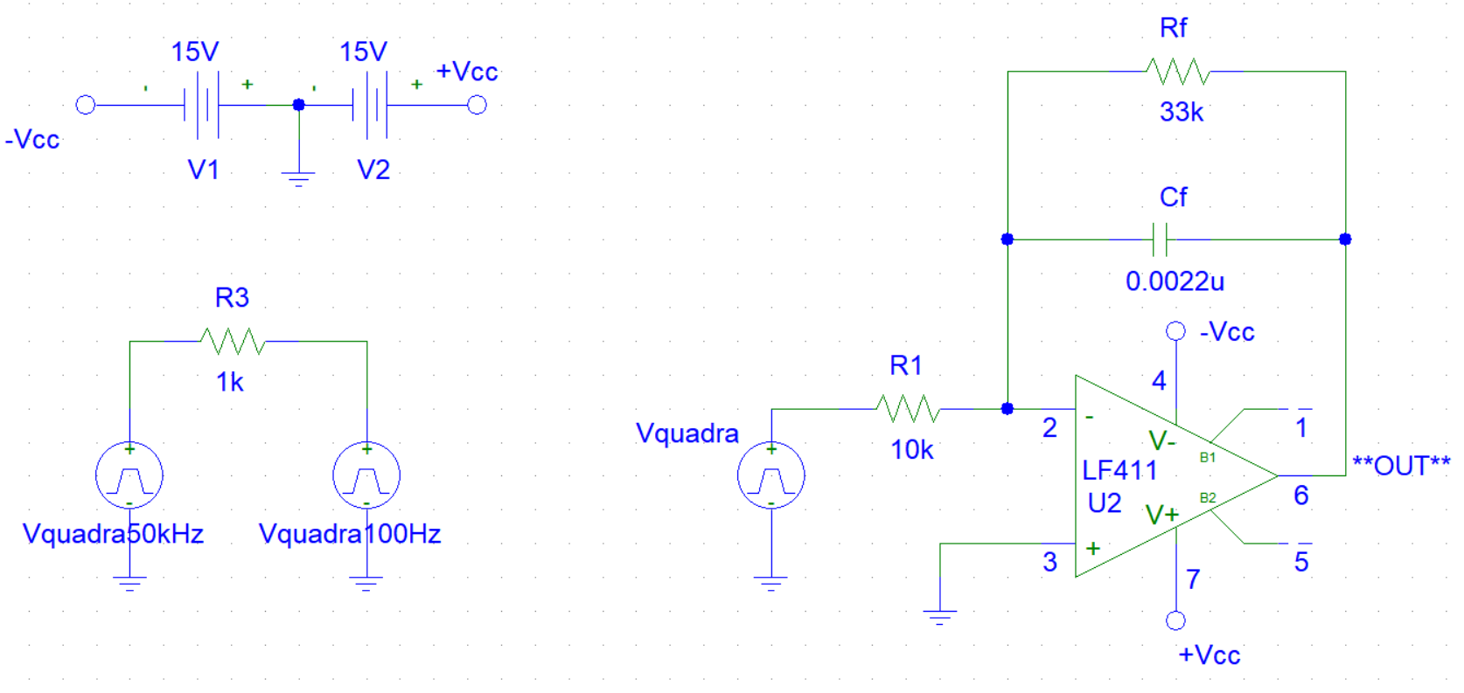**Graph:**

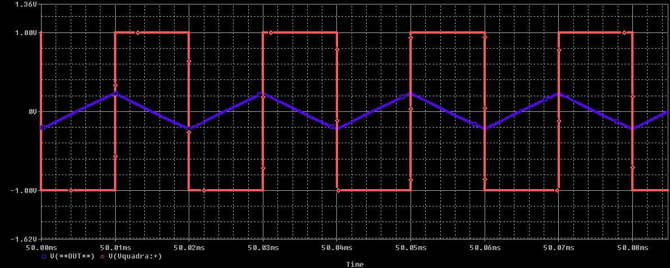

**Aim:** To Construct and simulate Differentiator OpAmp

**Theory:**

An op-amp differentiator or a differentiating amplifier is a circuit configuration which produces output voltage amplitude that is proportional to the rate of change of the applied input voltage. A differentiator with only RC network is called a passive differentiator, whereas a differentiator with active circuit components like transistors and operational amplifiers is called an active differentiator.

op-amp differentiator equation

**Circuit:**

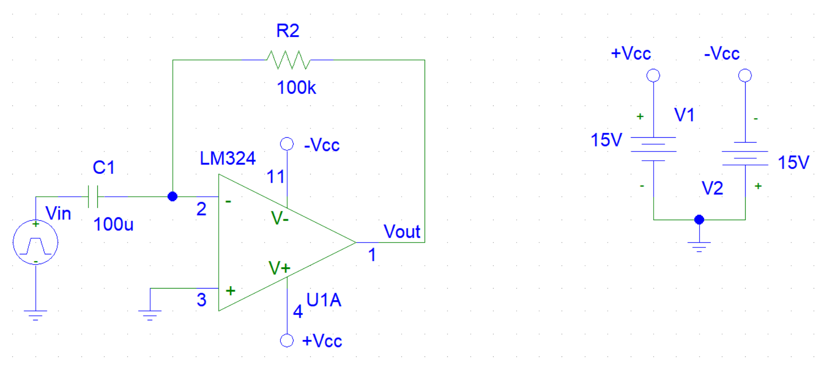

**Graph:**

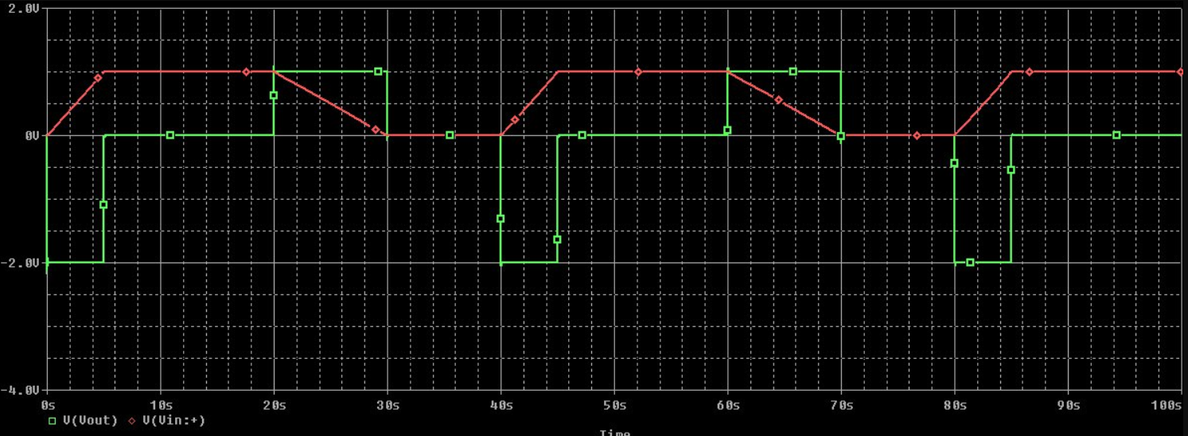

**Aim:** To Construct and simulate Inverting OpAmp

**Theory:**

In **Inverting Amplifier** circuit the operational amplifier is connected with feedback to produce a closed loop operation. When dealing with operational amplifiers there are two very important rules to remember about inverting amplifiers, these are: “No current flows into the input terminal” and that “V1 always equals V2”. However, in real world op-amp circuits both of these rules are slightly broken. **Negative Feedback** is the process of “feeding back” a fraction of the output signal back to the input, but to make the feedback negative, we must feed it back to the negative or “inverting input” terminal of the op-amp using an external **Feedback Resistor** called Rƒ. This feedback connection between the output and the inverting input terminal forces the differential input voltage towards zero.

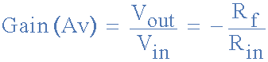

**Circuit:**

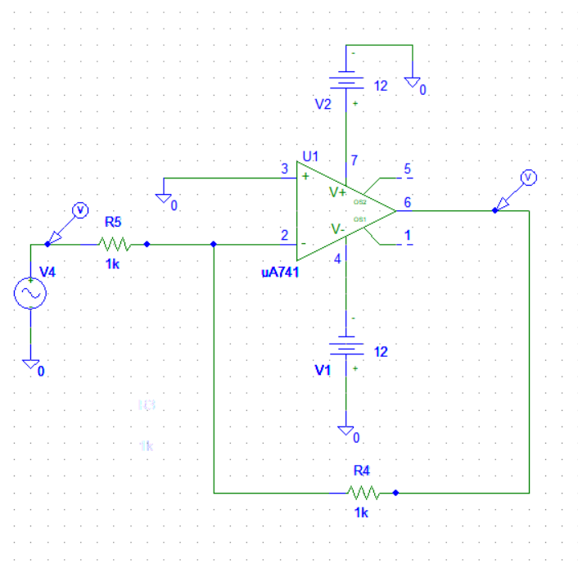

**Input:**

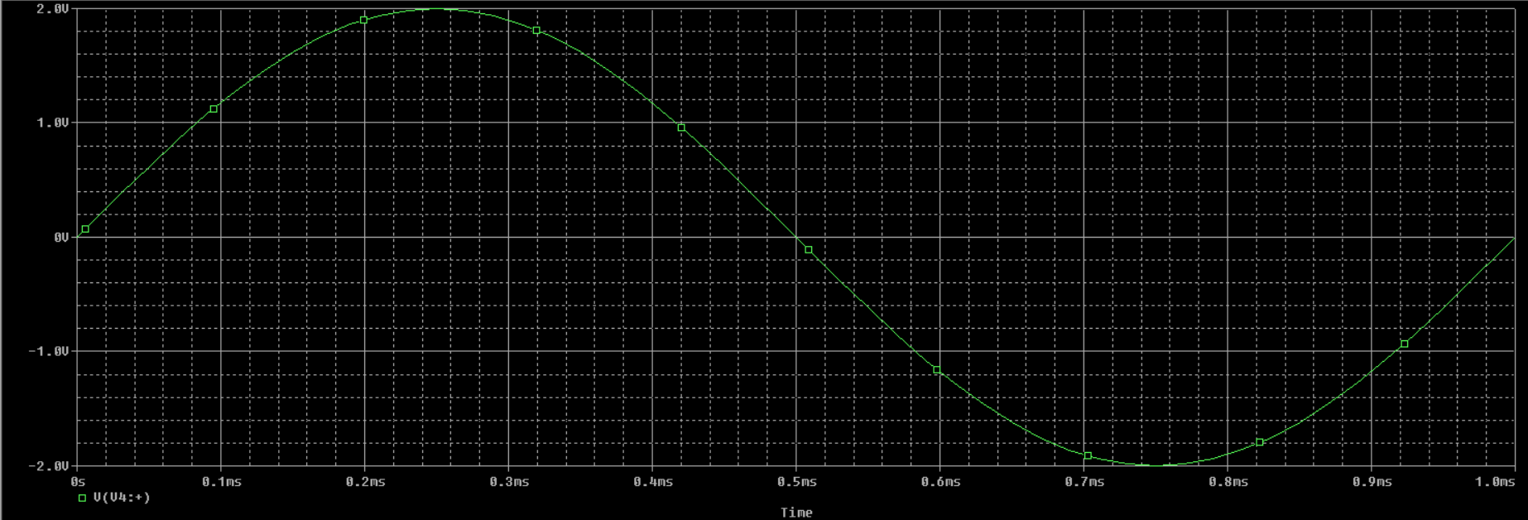

**Output:**

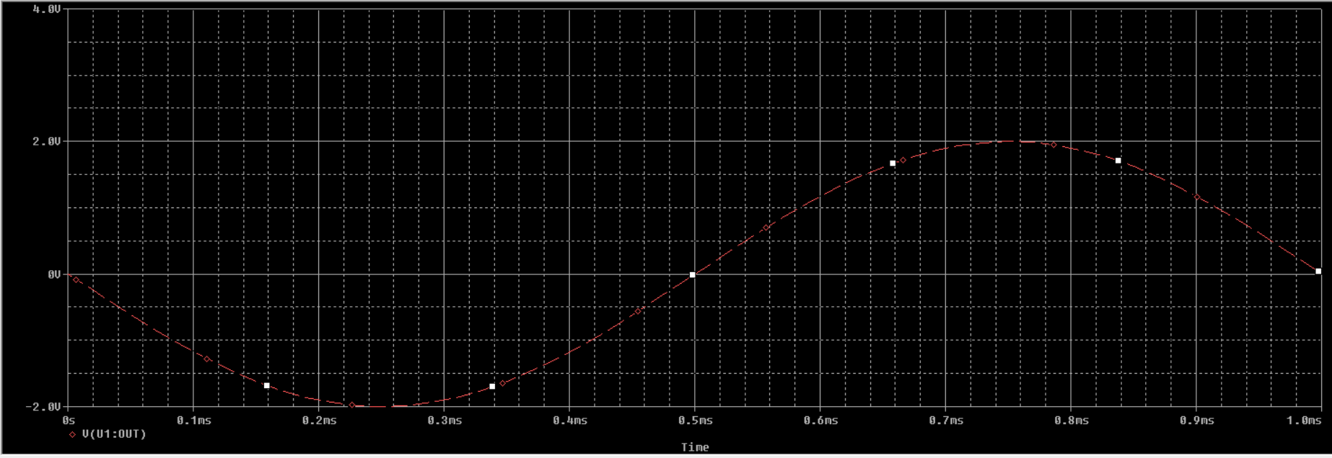

**Final:**

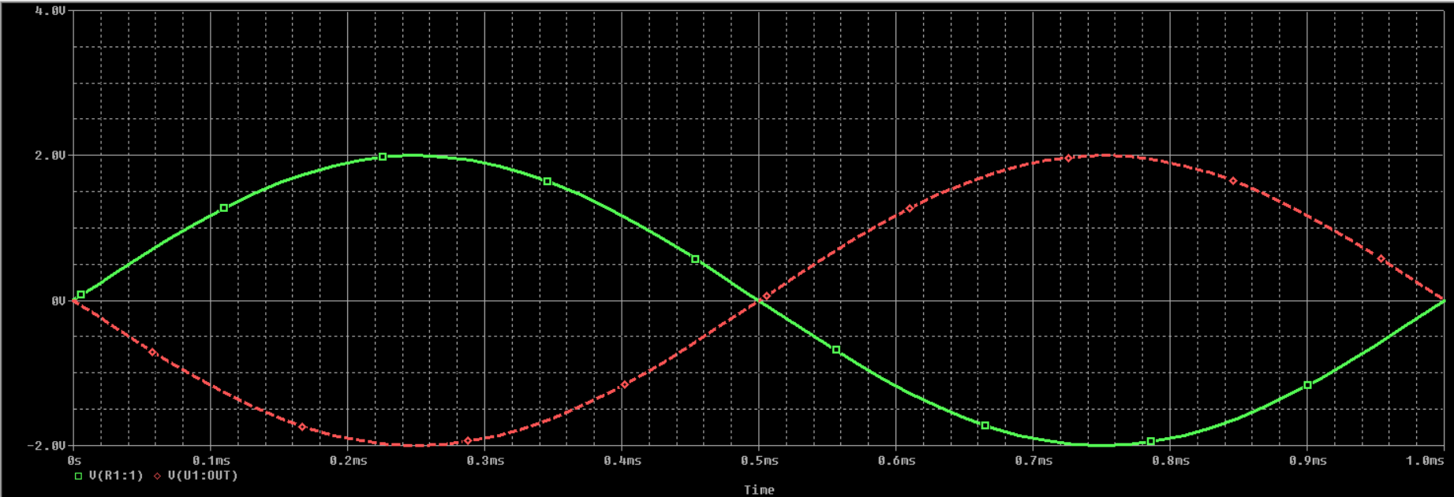

**Aim:** To Construct and simulate Non-Inverting OpAmp

**Theory:**

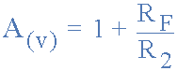

A non-inverting amplifier is an op-amp circuit configuration which produces an amplified output signal. This output signal of non-inverting op amp is in-phase with the input signal applied. In other words a non-inverting amplifier behaves like a voltage follower circuit. A non-inverting amplifier also uses negative feedback connection, but instead of feeding the entire output signal to the input, only a part of the output signal voltage is fed back as input to the inverting input terminal of the op-amp. The high input impedance and low output impedance of the non-inverting amplifier makes the circuit ideal for impedance buffering applications

**Circuit:**

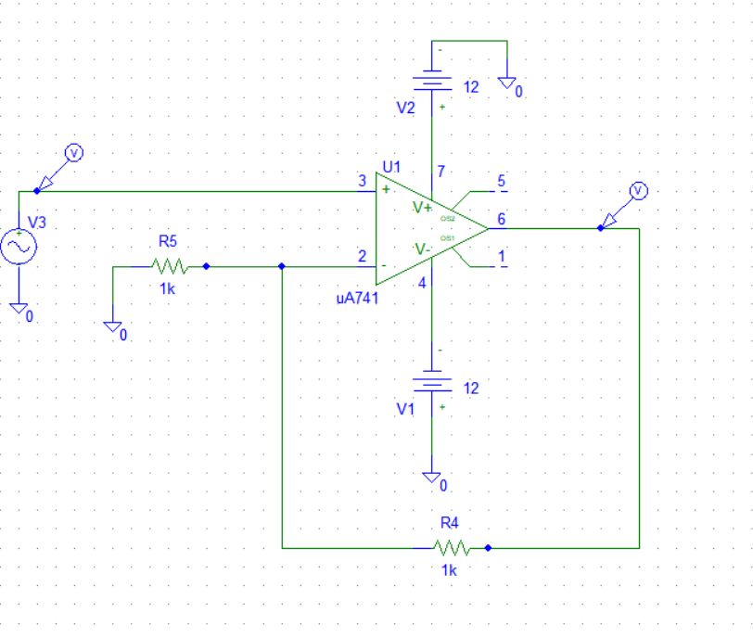

**Output:**

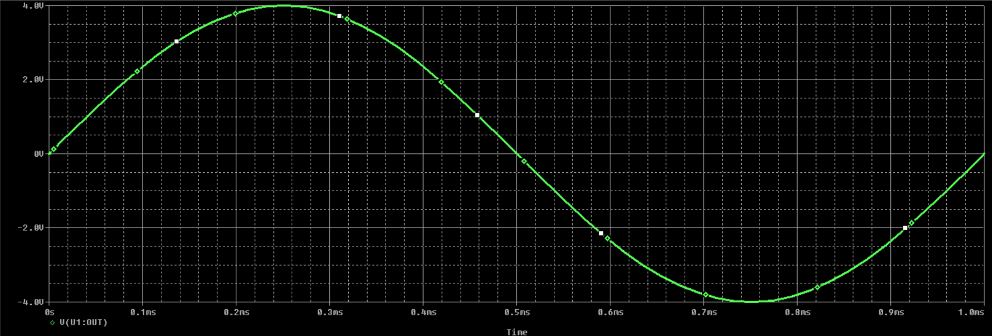

**Input:**

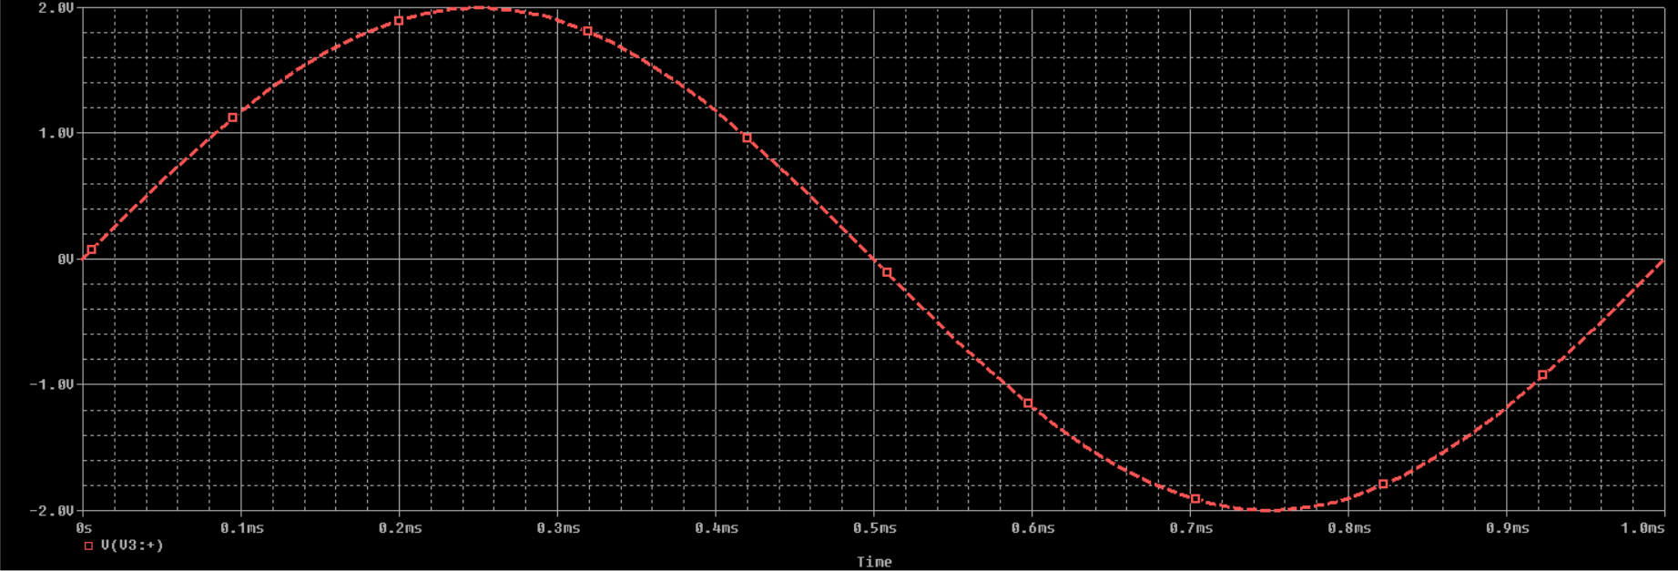

**Final:**

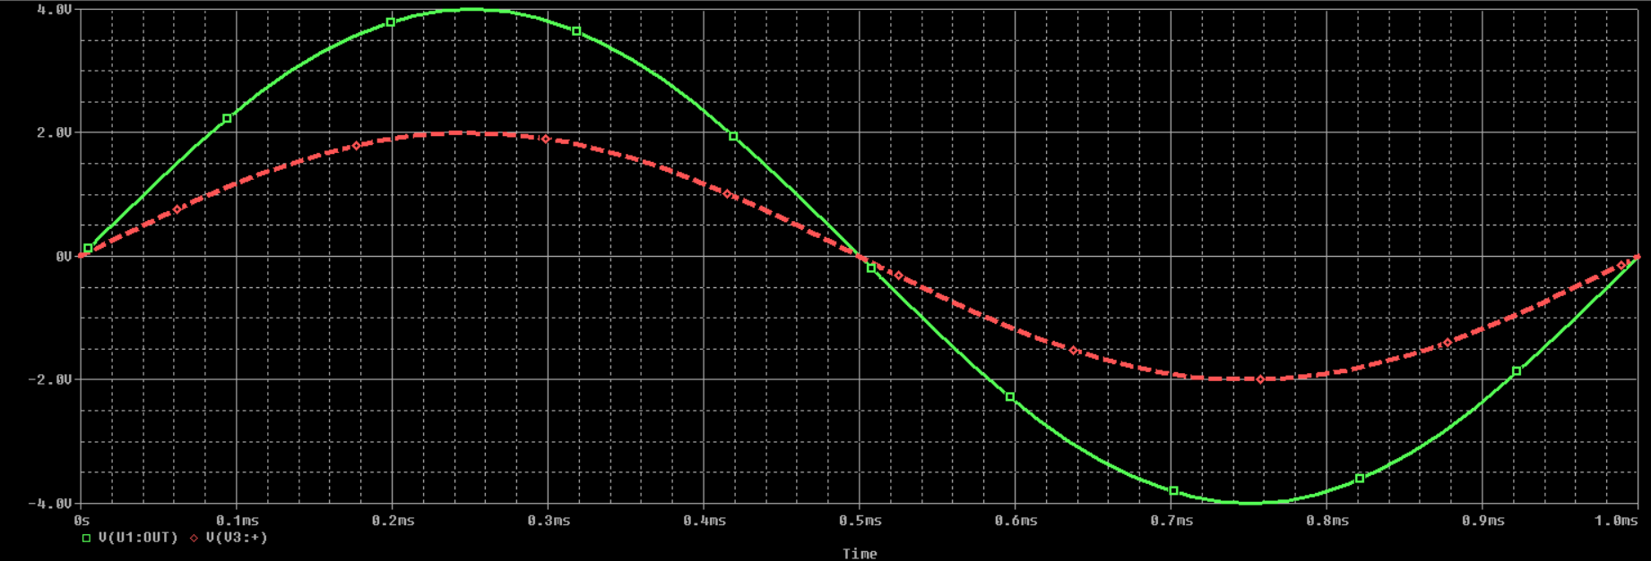

**Aim:** To Construct and simulate Voltage Follower OpAmp

**Theory:**

**Voltage follower** is an [Op-amp](https://www.electrical4u.com/op-amp-working-principle-of-op-amp/) circuit whose output [voltage](https://www.electrical4u.com/voltage-or-electric-potential-difference/) straight away follows the input voltage. That is output voltage is equivalent to the input voltage. Op-amp circuit does not provide any amplification. Thus, voltage gain is equal to 1. They are similar to discrete emitter follower. The other names of voltage follower are Isolation Amplifier, Buffer Amplifier, and Unity-Gain Amplifier. The voltage follower provides no attenuation or no amplification but only buffering. This circuit has an advantageous characteristic of very high input impedance.

**Circuit:**

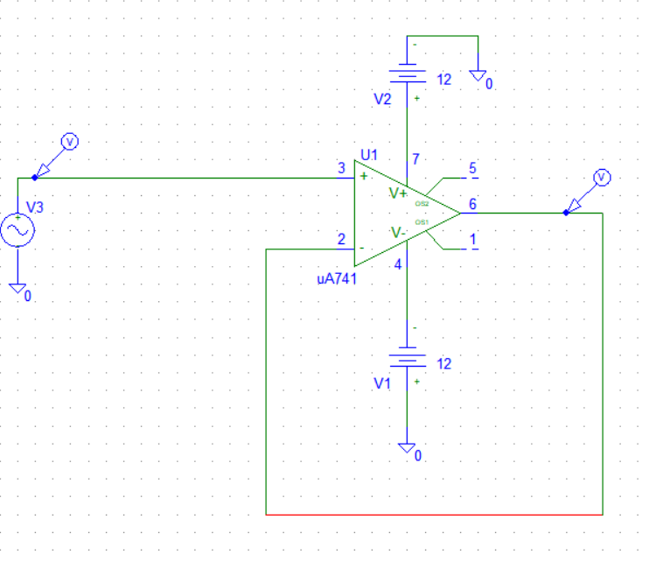

**Input:**

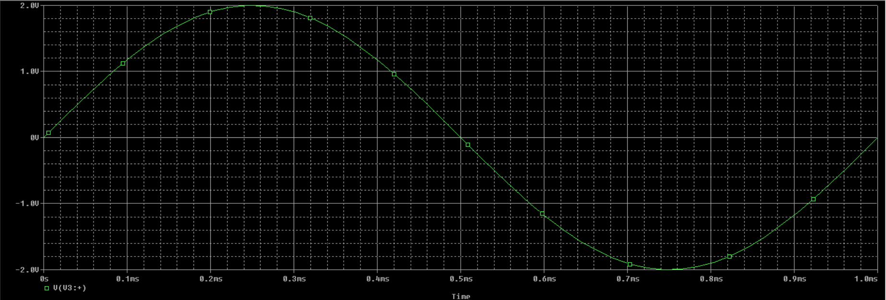

**Output:**

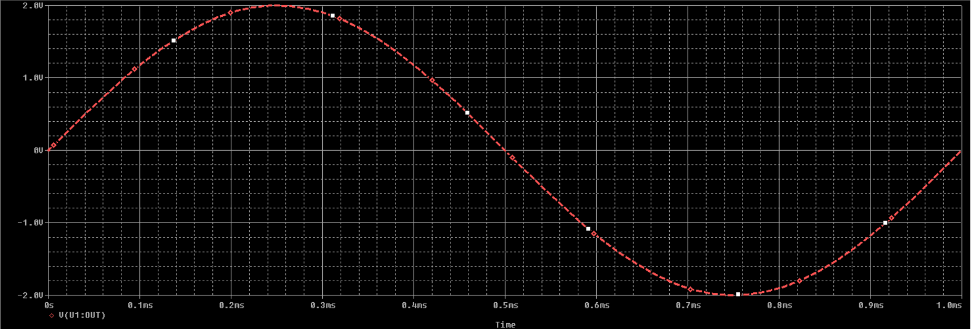

**Final:**

